Hainan Airlines Pet Transportation Services Product Description

Dear travelers:
Pets may experience undesirable environmental stressors during flights, including altitudinal pressure, confined space and others. Such factors may result in emotional and physiological changes, so we ask that you carefully consider such factors before choosing to transport pets via airplane.
For any unforeseen events or circumstances, including death, which occur during the process of transportation of customers’ pets, if there is no evidence to prove it is at fault, then, Hainan Airlines Company Limited disclaims all liability.
If you decide to use air shipment services for your pet, please read through the following information in order to prepare to transport your pet. HU wishes both you and your pet a pleasant journey!
1) Applicable range of travelers
Travelers bringing pets as checked baggage. Travelers utilizing pet transportation services will be allowed to meet with their pets at the airport terminals of the airports at their origins and destinations. During the flight, your pet will be able to enjoy the flight within an oxygenated cabin underneath the passenger cabin of the aircraft. Such services are only available at some airports. In regions where pets are not permitted to be taken on the same flights as travelers, please contact the local HU consignment or another company that offers pet transportation services.
2) Applicable routes
Applicable to self-run HU/CN domestic and international flights (excluding charter and code share flights)
3) Terms of pet transportation
(I) A pet refers to a domesticated household dog or cat that travels on the same plane as its owner and falls within the scope of stipulated weight requirements.
(Ii) Pets must be checked and cannot be taken on the plane within the passenger cabin as carry-on baggage.

(Iii) The airline does not provide a comprehensive pet transportation transfer service for connecting flights. Passengers must themselves make arrangements for each flight separately. As such, passengers must make arrangements for pet transportation during connecting flights after arriving at the airport of their connecting flight. For direct flights, arrangements for transportation of the pet to the final destination can be made at the airport of origin.
(Iv) Each passenger can only transport a maximum of two pets. The two pets need to be packed separately. The total weight (including pet, pet carrier, food and water) must not exceed 32 kg (inclusive).
(V) The transportation of guide dogs, hearing dogs, rescue dogs and other such working dogs is not subject to the limitations specified within paragraphs (ii) - (iv).
(Vi) Pets not suitable for air travel.
The following pets are not suitable for air travel. Please prudently consider whether the state of relevant pets adhere to conditions contained in the following statements.
1. Pets born less than six months before travel.
2. Pregnant pets or those that have given birth within 48 hours of takeoff.
3. Pets with ear, nose, or throat disorders and pets with disorders of the cardiovascular system, brain vascular system, respiratory system, or digestive system as well as pets that have had surgery within 48 hours of takeoff.
4. Pets with anxious or restless dispositions and pets that are fragile, weak, sensitive to high temperature and/or high altitude environment, or that cannot remain in a pet enclosure for long periods.
5. Pets that have been given tranquilizers or sleeping pills.
6. Pets that exude odors that are very pungent or difficult for humans to tolerate.
7 The following categories and breeds of pets are not suitable for air travel (see examples with pictures in Attachment 2):
1) Flat-nosed dogs or cats: All terrier, all boxer dogs, all bulldogs, all spaniel dogs, all molosser breeds, all pugs, all mastiffs, American Staffordshire dogs, pit bull terriers, Boston terriers, Brussels Griffon dogs, water spaniels, English Cocker Spaniels, English Toy Spaniels, Cavalier King Charles Spaniels, Bull Mastiffs, Griffon Bruxellois dogs, Affenpinscher dogs, Lhasa Apso dogs, Pekingese dogs, Chow Chows, Japanese Chin dogs, Japanese dogs, Shar Pei dogs, Shih Tzu dogs; Burmese cats, Himalayan cats, Persian cats, Exotic Shorthair cats.
2) “Fighting” Dogs: Pitbulls, Tosa dogs, Fila Brasileiro (Brazililian Mastiff) and its hybrids, Dogo Argentino dogs.
3) Breed unsuitable for high temperature and/or high altitude environments: Samoyed.
(Vii) HU is unable to provide service under the following circumstances.
1. When the model of aircraft does not permit the suitable transport of living animals. (For example: A340 models do not have a suitable cargo space and cannot transport pets under any circumstances).
2. The consignor has not completed the appropriate arrangements for pet transportation; for example, the shipping certification documents are not complete or the pet enclosure does not meet pre-conditions of transport.
3. The traveler does not accept HU pet transport conditions or requirements for the pet enclosure or refuses to complete pet transportation application documents.
4. Due to international security conditions abroad concerning airport ground handling, the transport of pets is not permitted on Irkutsk, Chita, Okinawa, Malé, and Bali routes. (If you chose to take an international flight with Hainan Airlines, please confirm that pet transportation is permitted when applying for pet transport with HU).
5. Due to special provisions applied for specific periods (for example: during epidemics).
4) Pet transportation documentation requirements
To facilitate transportation of the pet, please prepare the following transport-related documents.
(I) Domestic flights
1. An "animal quarantine certificate" as issued by the animal health authority with the "transport carrier sterilization" column completed with the animal health supervision and quarantine seal applied to the document.
2. Pet vaccination certificate.

(Ii) International flights
1. An "animal quarantine certificate" as issued by the animal health authority with the "transport carrier sterilization" column completed with the animal health supervision and quarantine seal applied to the document (needed prior to leaving the country).
2. Effective documentation for transport in/out of the country from the relevant government(s) (destination location/location of transfer).
3. Effective health statement and rabies vaccination certificate issued by the relevant authorities.
4. Gather the proper entry permits, health declarations, and vaccination certificates for all inbound trips / transit countries.
5. Any additional particular documents as required by the governments of countries on all inbound trips / transit countries. Refer to "TRAVEL INFORMATION MANUAL". consult the relevant consulates or embassies of the countries, or utilize the relevant national government websites in order to determine the documents that are required.
(Iii) Transportation applications (must be provided for all domestic and international flights).
Please read and fill out the "HU Pet Transport Application" (see Attachment 1), and sign the "Travelers Declaration" as well as the necessary "Additional Declaration”.
5) Kennel requirements
The pet enclosure is critical to the safe travel of the pet. As such, we must emphasize that you carefully read the following information in order to prepare a qualified enclosure for your pet.
(I) Pet enclosures that meet the following criteria are permitted
1. Must be a pet enclosure that is specially for the air transport of pets. It must be made of a sturdy material and must have a top that is fixed in place. At least three sides need to be ventilated. The enclosure must have a locking device that is composed of strong metal material. Once closed, the door must effectively prevent the escape of the pet by its own means.
2. The vents of the enclosure should be made of metal and securely attached to the enclosure. If the vents are made of non-metallic materials, ventilation holes that are round or of other shapes must be present.
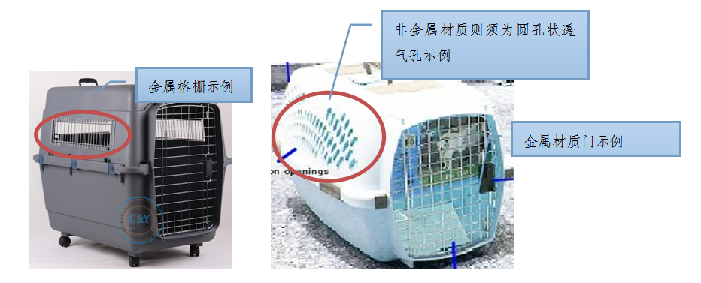
金属格栅示例：Example with metal grating
非金属材料则须为圆孔状透气孔示例：If non-metallic materials are used, ventilation holes that are round must be present.

金属材料门示例：Example of an enclosure with a metal door

3. All parts and accessories of the enclosure (including nuts, bolts, rivets, locks, etc.) must be firmly attached and in good working order.
4. The enclosure should have a handle or a sufficiently protruding edge that facilitates handling so that the loading and unloading process can proceed normally.
5. The enclosure should have a smooth bottom so that it can be placed on a flat surface without sliding. In the event that the chosen enclosure has wheels, the wheels need to be either fixed in place so that they do not move or removed from the enclosure to ensure that the enclosure does not slide during transport.
6. The enclosure’s size must be in compliance with IATA Live Animals Regulations (see details below) to ensure that the space provided is large enough for the pet to freely stand, sit down, turn around or lie down in a normal position within the enclosure.
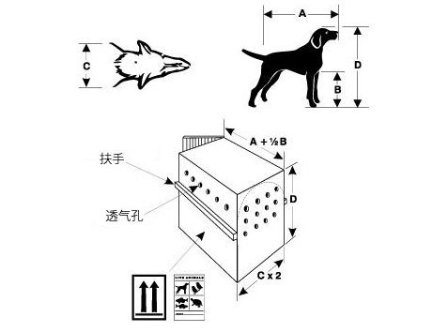
扶手：handrail

透气孔：air holes

(1)Explanation of dimensions:
A. Length from the tip of the nose to the base of the tail;
B. Distance from the base of the leg to ground level;
C. The maximum width of the pet;
D. Distance from the ground to the tip of the ear or the top of the head. When the pet is standing naturally, its ears must not touch the top of the enclosure.
(2) Enclosure size:
Length = A + ½ B
Width = C x 2
Height = D
7. The inside of the pet enclosure must be covered with absorbent padding (e.g. towels, blankets, pet diapers or white paper) to prevent contamination of other luggage through the leakage of pet excrement. Do not use absorbent padding that contains toxic substances (such as newspapers, etc.). These are the recommended standards. If travelers choose not to use absorbent padding in the enclosure or insist on lining the inside of the enclosure with articles that contain toxic substances, they must specify that they will bear any consequences of having done so in the "Pet Transport Application".
(Ii) The following types of pet enclosures may not be used for pet transport
1. Snap-together or foldable enclosures.
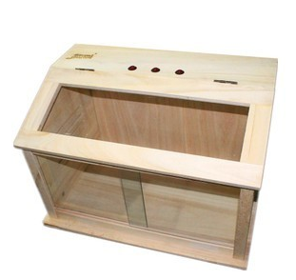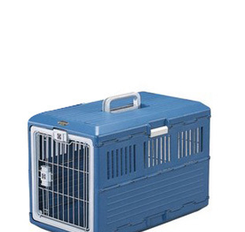
(snap-together enclosure) (foldable enclosure)
2. Enclosures made entirely from networks of welded metallic wire or wicker.
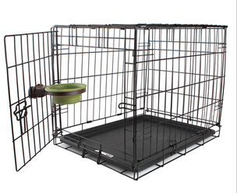
(typical example)
3. Enclosures with a door or ventilation openings on the top.
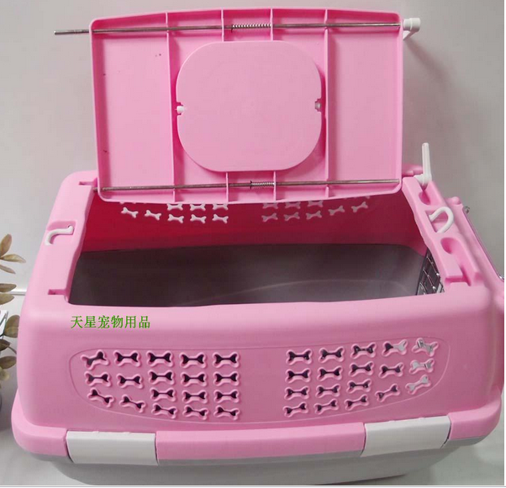
(typical example)
4. Enclosures with doors made of plastic or fiberglass.
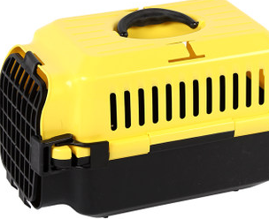
(typical example)
5. Enclosure made of a soft material or with a soft plastic ventilation grille (Method of evaluation: When pressed with one’s hand, an obvious concave deformity appears on the enclosure or the grille).
(Iii) The following types of pet enclosures may be used for pet transport so long as the passenger is willing to bear all risk associated with doing so.
1. An enclosure with plastic columnar grilles for ventilation. Because this sort of enclosure may have problems associated with its materials or construction, unexpected things are very likely to happen during the course of transport (such as accidents or sullying of/damage to others’ luggage resulting from pets escaping by biting the grille) Please engage in careful consideration before using this type of enclosure.
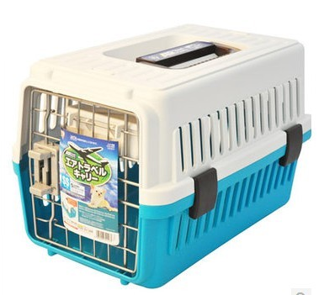
(typical example)
2. Passengers who insist on choosing such a pet enclosure need to make a special declaration and manually sign to attest to the fact that they will bear all the liability and risk associated with using the enclosure when completing the "HU Pet Transport Application". Hainan Airlines reserves the right to hold such passengers accountable for the damage and sullying of other passengers luggage as a result of pet escape.
3. When using the abovementioned pet enclosures for shipment, the requirements of Section 1, Article 5 besides Point 2 of this document must be adhered to.
(Iv) Pet enclosure packaging requirements
To further prevent pet escape, we recommend that you refer to the following instructions for the preparation of the cat enclosure.
1. For the safe transport of pets, it is recommended that travelers choose to use the protective screening provided by HU. You should wrap the protective screening on the pet enclosure and wrap it once again after affixing it in place.
2. When packing tape is used for the packing. The packing tape is required to be utilized in a protective outer layer of the protective screening. Medium Enclosures (volume greater than or equal to 81 × 55 × 58 cm, but smaller than 91 × 60 × 66 cm) should be bound at least two times (two layers) both vertically and horizontally using “tic-tac-toe” intersecting patterns on the top and bottom sides. Large Enclosures (greater than or equal 91 × 60 × 66 cm in volume) should be bound at least three times (three layers) both vertically and horizontally using intersecting patterns at the top and the bottom sides in an evenly distributed fashion. To avoid having to flip over the animals during the packaging process, the sides of the pet enclosures do not need to be horizontally wrapped with packing tape. Thus the packing tape on the sides will be wrapped in a parallel vertical manner. When packaging is required, wrap the packing tape through the enclosure door grille and protective grilles, bringing the tape in through one hole in the grille and bringing it out through another one using regular spacing intervals. The goal is to provide the function of firmly affixing the door and enclosure itself together with the protective screening as one unified unit. Properly packaged examples are as follows:
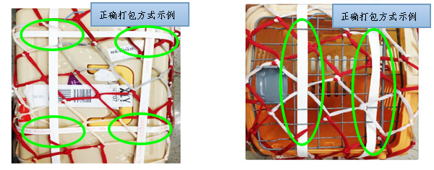
正确打包方式示例Properly packaged examples

正确打包方式示例Properly packaged examples
(typical example)
6) Requirements for shipping application and handling
(I) Due to the need to make arrangements prior to the provision of pet transport service and to allow you to have ample time to prepare for pet travel, please submit your application for pet transportation to Hainan Airlines 24 hours prior to the day of the flight. Passengers with flights leaving from within the country Originating domestic can apply for pet transport at an HU ticket office or by phone at 950718. Overseas visitors can apply for pet transport by dialing a relevant sales phone number or getting in touch with a relevant overseas sales office.
(Ii) If application is not made in advance and it must be made on the day of the flight, the application procedures must be carried out at the airport’s HU check-in counter two hours before the takeoff of the relevant flight.. However, under such circumstances, there would be no way to confirm in advance that the relevant flight does in fact have an oxygenated storage cabin that is suitable for the transport of live animals. Thus, to facilitate the successful transport of the pet, we strongly recommend that you do not use this method of applying for pet transport.
(Iii) No matter which method is used to apply for the service, you will need to bring the pet, the pet enclosure box, the "Pet Transport Application", as well as the required supporting documents to an HU counter to complete the pet shipment procedures.

7) Fee scale
(1)Pet shipment fee scale
1. Pet weight, which includes the weight of the pet, enclosure, and food, are not included in the free baggage allowance, fees for excess baggage shall be applicable.
2. The weight calculation system for excess baggage charges: charge = per kg fee × total weight in kg. Note: The standard fee per kg is the price of an ordinary, economy-class, one-way direct flight ticket × 1.5%. The total weight subject to charge is the total weight of the pet, the enclosure, and food.
3. Piece system of excess baggage charges: Total amount of charges = charge multiplier (determined based on the weights and volumes of pets and pet enclosures) × the fee from the fee scale. (Note: "The fee from the fee scale" mentioned here refers to one piece of excess baggage on the piece-rate system for an economy-class passenger seat. However, the fee associated with weight and volume for non-excess baggage varies in accordance with the scale associated with the particular route at the particular time. Please review the information on HU’s official website with regards to baggage information or inquire through the service hotline at 950718).
① Fee multipliers for China-US and China-Canada routes：

Transport method | Size | Weight (pet+enclosure): represented by X
Transport method | Size | X＜32Kg | X≥32Kg
As checked baggage | Small 53×38×40cm | Multiplier = 1 | Will be taken as freight transport. Please contact HU’s shipping unit.
As checked baggage | Moderate 68×50×48cm | Multiplier = 2
As checked baggage | Medium 81×55×58cm | Multiplier = 2
As checked baggage | Large 91×60×66cm | Multiplier = 3
As checked baggage | Very Large 101×68×76cm | Multiplier = 3
As checked baggage | Extremely Large 121×81×88cm | Multiplier = 3
② Piece system used for other routes (European, Moscow, St. Petersburg routes, Busan, Thailand, Singapore, Almaty routes and other new routes utilizing a piece system as designated by the marketing department). Related fee multipliers are as follows:

Shipping method | Size | Weight (pet+enclosure): represented by X
Shipping method | Size | X≦23KG | 23＜X＜32Kg | X≥32Kg
As checked baggage | Small 53×38×40cm | Multiplier = 1 | Multiplier = 1 | Will be taken as freight transport. Please contact HU’s shipping unit.
As checked baggage | Moderate 68×50×48cm | Multiplier = 1 | Multiplier = 2
As checked baggage | Medium 81×55×58cm | Multiplier = 1 | Multiplier = 2
As checked baggage | Large 91×60×66cm | Multiplier = 2 | Multiplier = 3
As checked baggage | Very Large 101×68×76cm | Multiplier = 2 | Multiplier = 3
As checked baggage | Extremely Large 121×81×88cm | Multiplier = 2 | Multiplier = 3
(Ii) Declared value
1. Pet shipment declared value provisions
⑴ Handling preconditions: Hainan Airlines domestic flights only. If travelers opt to declare the value of pets being shipped, they must provide relevant authentication (such as the purchase invoice for the pet, etc.) showing that the actual value of the pet is more than 100 yuan per kilogram.
⑵ Restrictions: Each passenger may only have a maximum declared value of 8,000 yuan per pet being shipped.
(3) The declared value can only refer to the pet itself, not the enclosure.
(4) When there is any doubt as to the relevancy of the declared value and the passenger refuses the carrying out of a relevant inspection, HU reserves the right to refuse to transport the pet.
2. Declared value surcharge
(1) Calculation method: When a passenger declares value for a pet, an additional fee shall be paid in accordance with the declared value amount. The fee shall be 5‰ of the amount of per kilogram declared value over 100 yuan. The formula is as follows: Declared value surcharge= (per kg passenger declared value -100 yuan per kg) × the weight in kilograms of the subject of the declared value × 5 ‰.
Example: If the passenger’s baggage is 10 kg and he declares a declared value of 750 yuan per kg, the declared value surcharge shall be: (750-100) × 10 × 5 ‰ = 32.5 (yuan).
(2) Declared value surcharge fees are paid in RMB and rounded off.
8) Other policies
(I) In the event that a pet cannot be transported because the pet enclosure does not meet the requirements, the responsibility will be borne by the traveler.
(ii) When a traveler has applied for pet shipment at least 24 hours in advance and already received an acknowledgement that the shipment will be permitted, if on the day the pet will be checked for transport the pet is not able to be transported in an oxygenated cargo hold due to a technical problem or change of plane, HU may endorse the ticket for a later flight free of charge. In the event that the cargo hold is not suitable or otherwise unavailable for the needs of pet shipping and the traveler only initiated the request for the pet shipment on the same day as the flight, the responsibility will be borne by the traveler.

Attachment 1:

Attachment 2:
Typical examples of pets deemed unsuitable for air travel

Category | Breed |  |  | Picture | Comments
Flat-Nosed Cats | Burmese cat |  |  | 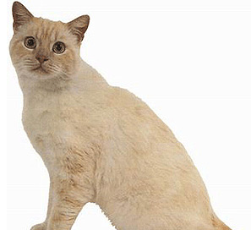
Flat-Nosed Cats | Himalayan cat |  |  | 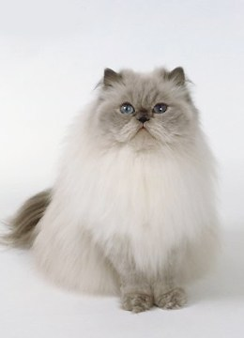
Flat-Nosed Cats | Persian |  |  | 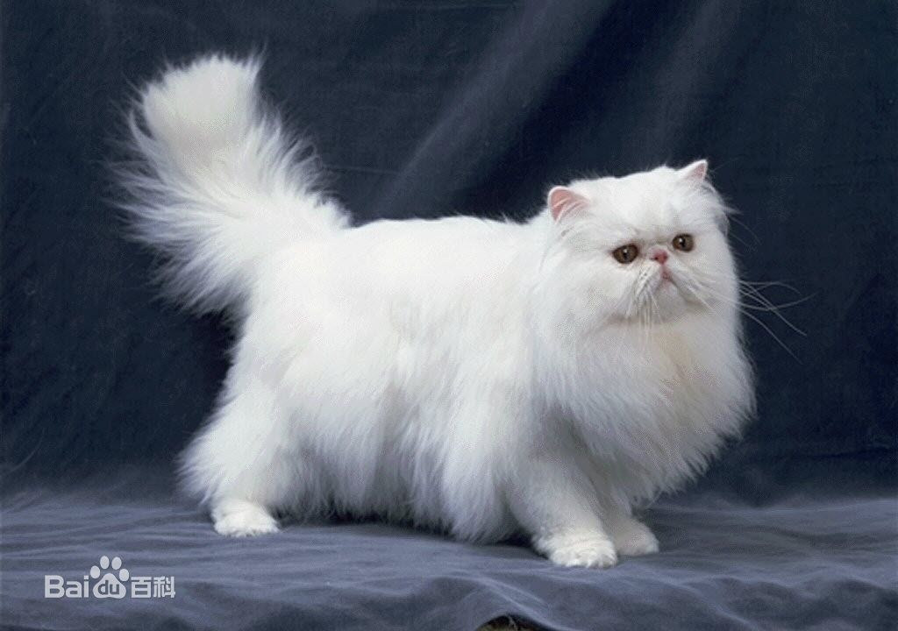
Flat-Nosed Cats | Exotic Shorthair. |  |  | 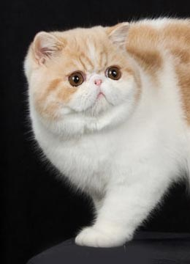
Flat-nosed Dogs | Terrier |  |  | 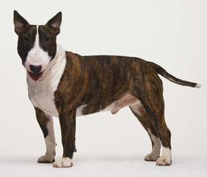
Flat-nosed Dogs | Boxer |  |  | 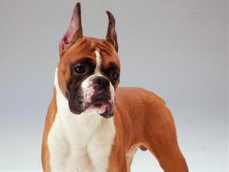
Flat-nosed Dogs | Bulldog |  |  | 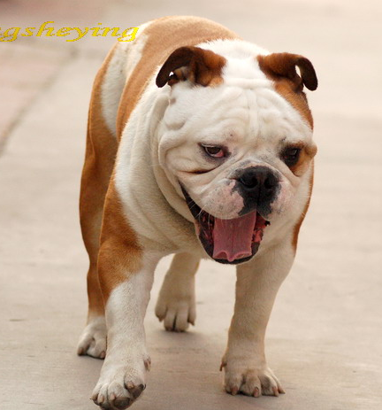
Flat-nosed Dogs | Spaniel dog |  |  | 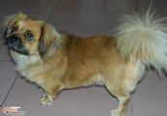
Flat-nosed Dogs | Molosser breeds |  |  | 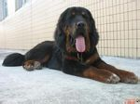
Flat-nosed Dogs | Pug |  |  | 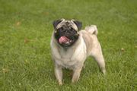
Flat-nosed Dogs | Mastiff |  |  | 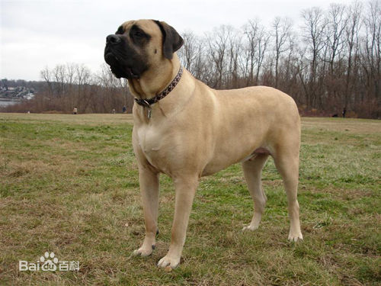
Flat-nosed Dogs | American Staffordshire dogs |  |  | 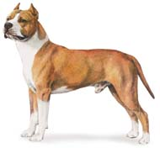
Flat-nosed Dogs | Pit bull terriers |  |  | 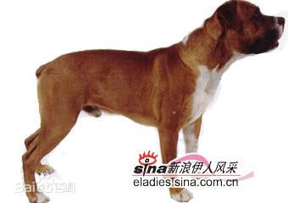
Flat-nosed Dogs | Boston terrier |  |  | 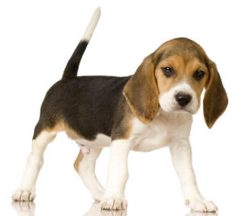
Flat-nosed Dogs | Brussels Griffon |  |  | 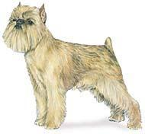
Flat-nosed Dogs | Water spaniels |  |  | 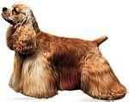
Flat-nosed Dogs | English Cocker Spaniel |  |  | 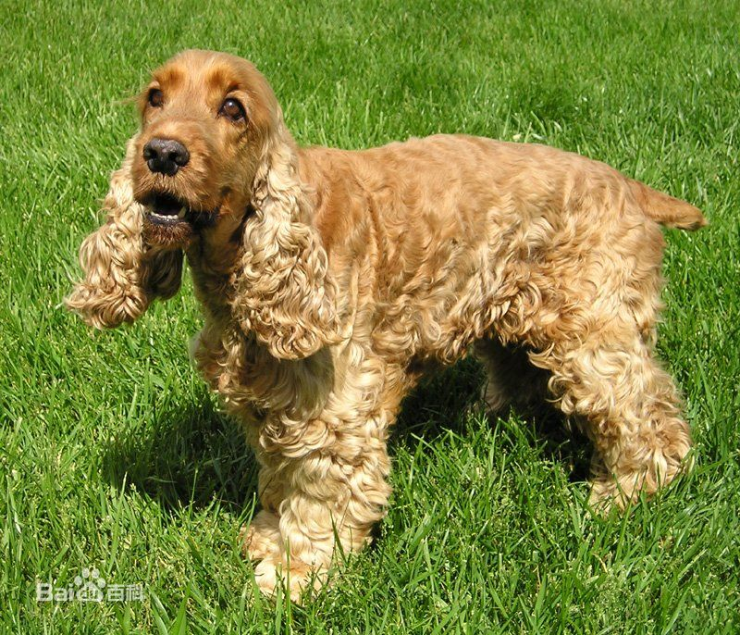
Flat-nosed Dogs | English Toy Spaniel |  |  | 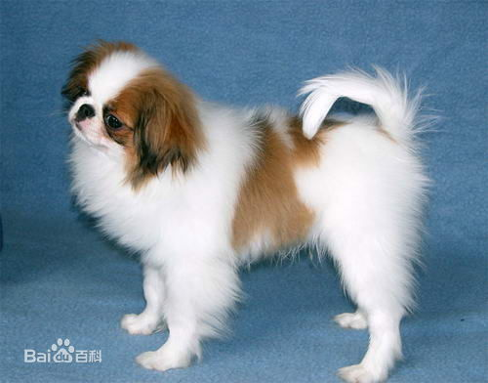
Flat-nosed Dogs | Cavalier King Charles Spaniel |  |  | 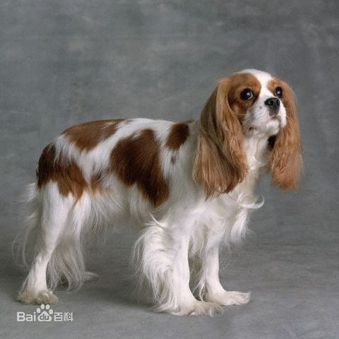
Flat-nosed Dogs | Bull Mastiff |  |  | 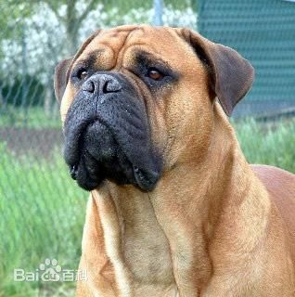
Flat-nosed Dogs | Griffon Bruxellois dogs |  |  | 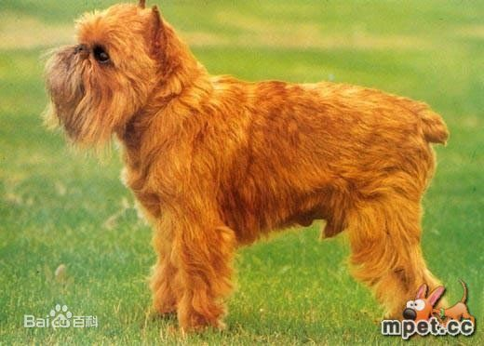
Flat-nosed Dogs | A Fenping Ka dogs |  |  | 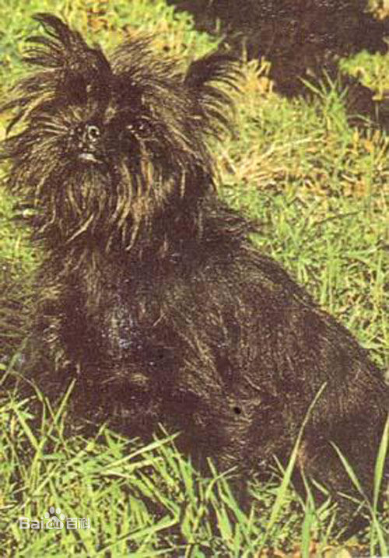
Flat-nosed Dogs | Lhasa Apso |  |  | 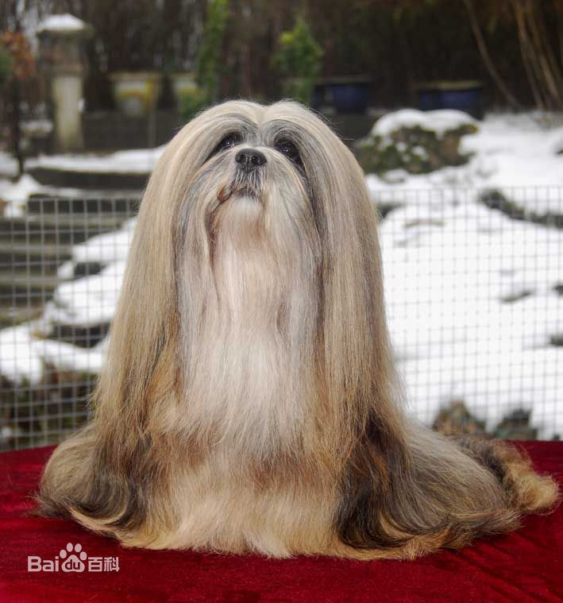
Flat-nosed Dogs | Pekingese dogs |  |  | 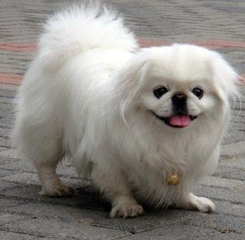
Flat-nosed Dogs | Chow Chow |  |  | 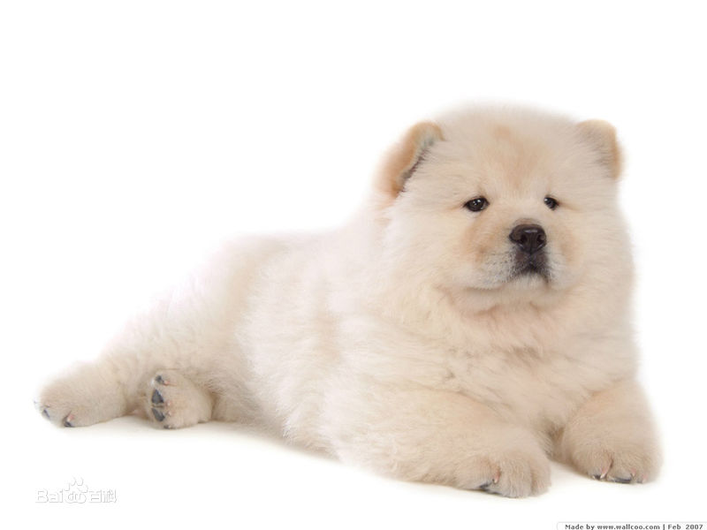
Flat-nosed Dogs | Japanese Chin dogs |  |  | 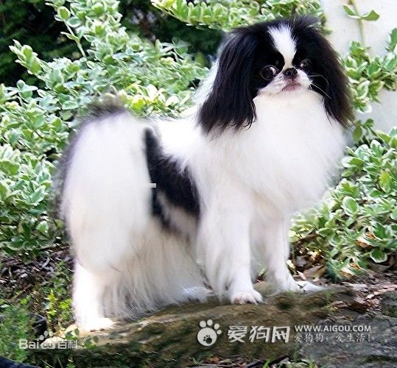
Flat-nosed Dogs | Japanese Breeds | Japanese Akita |  | 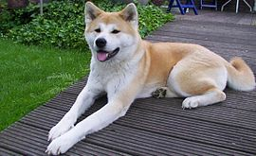 | (“Japanese Breeds” is a collective term that refers to dogs native to Japan and includes these six breeds)
Flat-nosed Dogs | Japanese Breeds | Kai |  | 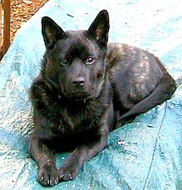
Flat-nosed Dogs | Japanese Breeds | Kishu |  | 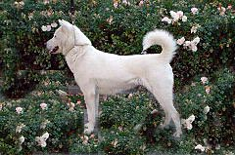
Flat-nosed Dogs |  |  | Shiba Inu | 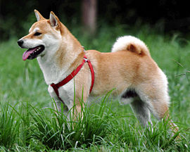
Flat-nosed Dogs |  |  | Shikoku | 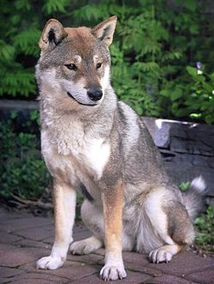
Flat-nosed Dogs |  |  | Hokkaido | 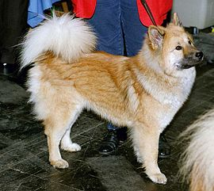
Flat-nosed Dogs | Shar Pei |  |  | 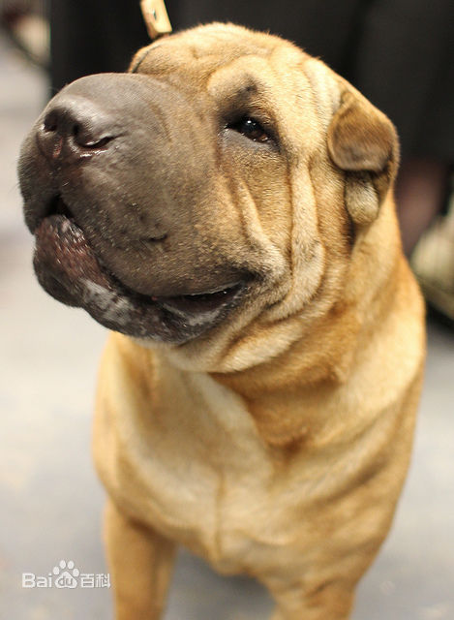
Flat-nosed Dogs | Shih Tzu |  |  | 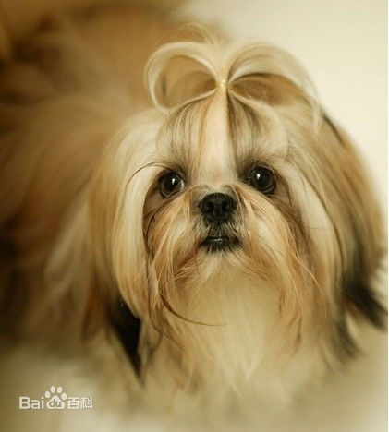
“Fighting” Dog Breeds | Pitbull |  |  | 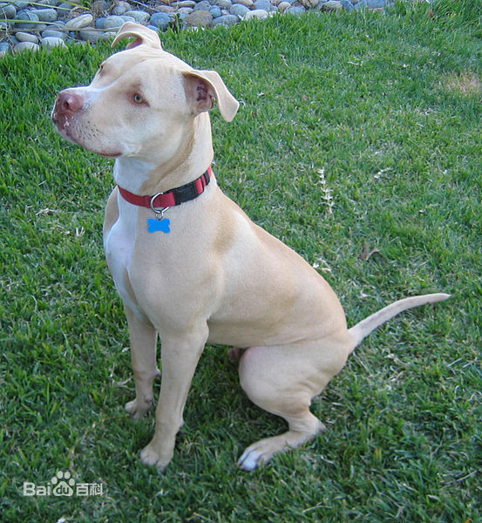
“Fighting” Dog Breeds | Tosa |  |  | 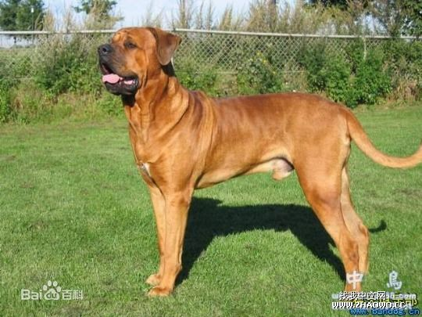
“Fighting” Dog Breeds | Fila Brasileiro (Brazililian Mastiff) and its hybrids |  |  | 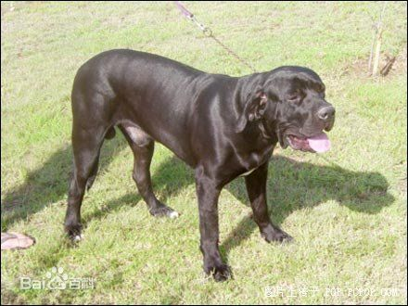
“Fighting” Dog Breeds | Dogo Argentino |  |  | 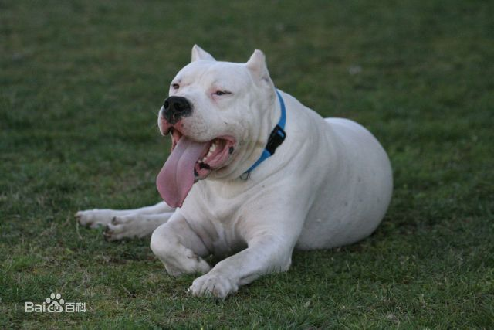
Other | Samoyed |  |  | 